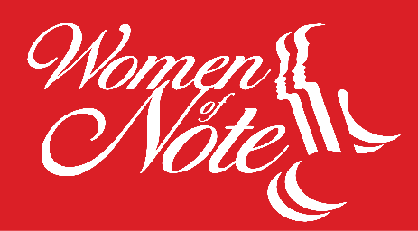 Booking Information
Bringing joy through harmony…
About Us
Women of Note is Region #9’s champion a cappella chorus. We will be competing at Sing United International competition in both 2026 and 2027. We embrace women of varying levels of vocal skills and diverse backgrounds to share the joy of harmony with each other and the community.
Founded in 1997 with the goal to create a large chorus in the community that would promote musical excellence in 4-part a cappella harmony, Women of Note members are women of all ages and musical abilities that together create, learn, inspire and share. Under the direction of Alex Rubin, the chorus blends the rich tradition of barbershop harmony with all types of music and performs a variety of repertoire that is enjoyed by audiences of all ages. Women of Note performs throughout the tri-county area for groups of all sizes, from intimate gatherings to public events and is a chapter of Sweet Adelines International know more recently as Sing United International.
Women of Note have had the pleasure of singing at venues such as the Flagler Museum, the Norton Museum of Art, the Adrienne Arscht Center for the Performing Arts and the Kravis Center for the Performing Arts, as well as for non-profit organizations such as The Red Cross, the American Heart Association, the American Cancer Society and the Susan G. Komen Breast Cancer Foundation. In addition to their busy performance schedule, the chorus competes regionally and internationally and has consistently earned top 5 placements in competition.
The chorus holds open rehearsals on Monday evenings at 7 PM at the United Methodist Church of the Palm Beaches and welcomes any woman who loves to sing! Women of Note is also available for hire for private parties and community events. For more information about Women of Note, a 501 (c) 3 non-profit organization, visit www.womenofnote.com or call 1-877-966-7464.
Ensemble Options
Women of Note can be hired as a full chorus, or an ensemble. Let us know your needs, and the full chorus or a smaller ensemble from the chorus. There is also a quartet for hire available for performances.
www.womenofnote.com

